**Project Title**

Revolutionizing Liver Care : Predicting Liver Cirrhosis using Advanced Machine Learning Techniques

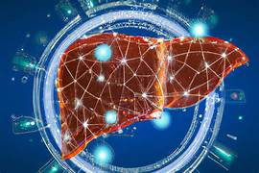

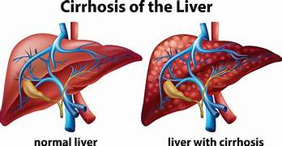

**Introduction:**

Here's a compelling introduction for the topic **"Revolutionizing Liver Care: Predicting Liver Cirrhosis Using Advanced Machine Learning Techniques"**:

**🧬 Introduction**

Liver cirrhosis is a progressive and potentially fatal condition marked by irreversible scarring of liver tissue, often resulting from chronic liver diseases such as hepatitis, fatty liver disease, or long-term alcohol abuse. Globally, cirrhosis poses a significant burden on healthcare systems, with millions affected and many cases going undetected until advanced stages.

Traditional diagnostic methods rely heavily on invasive procedures and late-stage symptoms, which limits the potential for early intervention. This is where **machine learning (ML)** steps in as a game-changer.

By harnessing the power of ML algorithms, researchers and clinicians can now analyze vast and complex datasets—including biochemical markers, demographic data, imaging scans, and patient history—to predict the onset and progression of liver cirrhosis with remarkable accuracy. These predictive models not only enhance early detection but also support personalized treatment planning and efficient resource allocation in clinical settings.

This project aims to develop and deploy a robust ML-based predictive framework that revolutionizes liver care by enabling timely diagnosis and proactive management of cirrhosis, ultimately improving patient outcomes and reducing healthcare costs.

**Architecture:**

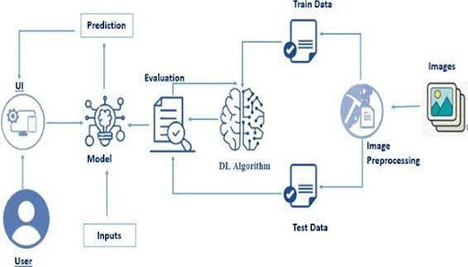

**System Workflow Overview**

Here's a comprehensive **System Workflow Overview** for the project *"Revolutionizing Liver Care: Predicting Liver Cirrhosis Using Advanced Machine Learning Techniques"*:

**🔄 System Workflow Overview**

This workflow outlines the end-to-end process of building and deploying a predictive model for liver cirrhosis using machine learning:

**🧩 1. Data Acquisition**

* **Sources**: Clinical databases, EHR systems, lab reports, imaging scans
* **Types of Data**:
  + Demographics (age, gender)
  + Biochemical markers (bilirubin, albumin, AST/ALT)
  + Lifestyle factors (alcohol use, diet)
  + Historical diagnoses

**🧼 2. Data Preprocessing**

* **Cleaning**: Handle missing values, remove outliers
* **Encoding**: Convert categorical variables to numerical
* **Normalization**: Scale features for uniformity
* **Balancing**: Apply SMOTE to address class imbalance

**🧠 3. Feature Engineering**

* **Selection**: Use domain knowledge and statistical methods (e.g., RFE)
* **Transformation**: Create new features from existing ones (e.g., AST/ALT ratio)

**⚙️ 4. Model Development**

* **Algorithms Used**:
  + Random Forest
  + XGBoost
  + AdaBoost
  + Logistic Regression
* **Training**: Use stratified k-fold cross-validation
* **Evaluation Metrics**: Accuracy, Precision, Recall, F1-score, ROC-AUC

**🔧 5. Model Optimization**

* **Hyperparameter Tuning**: GridSearchCV or RandomizedSearchCV
* **Regularization**: Prevent overfitting with L1/L2 penalties

**🧪 6. Model Validation**

* **Test Set Evaluation**: Final performance check
* **Clinical Feedback Loop**: Incorporate expert review for model refinement

**🚀 7. Deployment**

* **Interface**: Web dashboard or EHR integration
* **Backend**: Flask or FastAPI
* **Containerization**: Docker for scalable deployment
* **Security**: Ensure HIPAA compliance for patient data

**📈 8. Monitoring & Updates**

* **Performance Tracking**: Monitor predictions over time
* **Model Retraining**: Periodic updates with new data

**Prerequisites**

**Here are the key prerequisites for building and understanding the project *"Revolutionizing Liver Care: Predicting Liver Cirrhosis Using Advanced Machine Learning Techniques"*:**

**🧠 Knowledge Prerequisites**

**To effectively develop and deploy this system, you should be familiar with:**

**📊 Machine Learning Fundamentals**

* **Supervised learning (classification)**
* **Ensemble methods (Random Forest, XGBoost, AdaBoost)**
* **Model evaluation metrics (Accuracy, Precision, Recall, ROC-AUC)**

**🧪 Medical Domain Understanding**

* **Liver anatomy and physiology**
* **Common liver biomarkers (bilirubin, albumin, AST/ALT)**
* **Risk factors for cirrhosis (alcohol use, hepatitis, obesity)**

**🧹 Data Science Skills**

* **Data cleaning and preprocessing**
* **Feature engineering and selection**
* **Handling class imbalance (e.g., SMOTE)**

**🧰 Programming & Tools**

* **Python: Core language for ML development**
* **Libraries: Pandas, NumPy, Scikit-learn, Matplotlib, Seaborn**
* **Model Deployment: Flask or FastAPI, Docker for containerization**

**🗂️ Technical Prerequisites**

| **Category** | **Tools/Skills Required** |
| --- | --- |
| **Programming** | **Python, Jupyter Notebook** |
| **ML Libraries** | **Scikit-learn, XGBoost, imbalanced-learn** |
| **Data Handling** | **Pandas, NumPy** |
| **Visualization** | **Matplotlib, Seaborn** |
| **Deployment** | **Flask/FastAPI, Docker** |
| **Version Control** | **Git, GitHub** |

**📚 Suggested Resources**

**Project Objectives**

**Project Flow:**

**Here's a clear and structured Project Flow for *"Revolutionizing Liver Care: Predicting Liver Cirrhosis Using Advanced Machine Learning Techniques"*, based on the implementation described in the** [**GitHub repository**](https://github.com/Aniking001/Revolutionizing-Liver-Care-Predicting-Liver-Cirrhosis-Using-Advanced-Machine-Learning-Techniques)**:**

**🔄 Project Flow Overview**

**1️⃣ Project Initialization and Planning**

* **Define objectives: early detection of liver cirrhosis**
* **Identify relevant patient data sources**
* **Select appropriate ML techniques and evaluation metrics**

**2️⃣ Data Collection and Preprocessing**

* **Gather clinical data: age, gender, liver enzyme levels, bilirubin, albumin, etc.**
* **Handle missing values and outliers**
* **Encode categorical variables**
* **Normalize and scale features**
* **Apply SMOTE to balance classes**

**3️⃣ Model Development**

* **Train multiple models:** 
  + **Random Forest**
  + **XGBoost**
  + **AdaBoost**
  + **Logistic Regression**
* **Use stratified k-fold cross-validation**
* **Evaluate using metrics like accuracy, precision, recall, F1-score, ROC-AUC**

**4️⃣ Model Optimization and Tuning**

* **Perform hyperparameter tuning using GridSearchCV**
* **Apply regularization techniques to prevent overfitting**
* **Compare model performance and select the best-performing model**

**5️⃣ Executable Deployment**

* **Build a user-friendly interface (e.g., web dashboard)**
* **Deploy using Flask or FastAPI**
* **Containerize with Docker for scalability**
* **Ensure data privacy and compliance with medical standards**

**Project Structure**

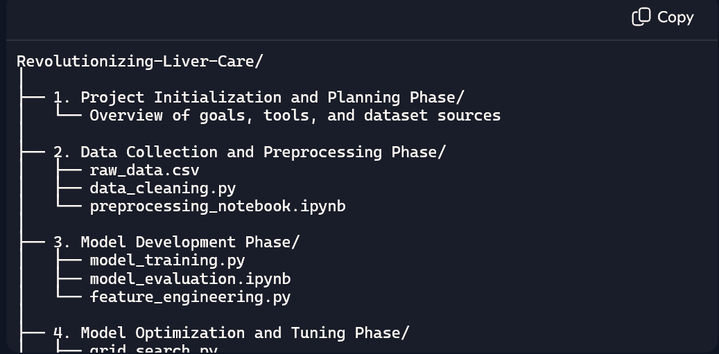

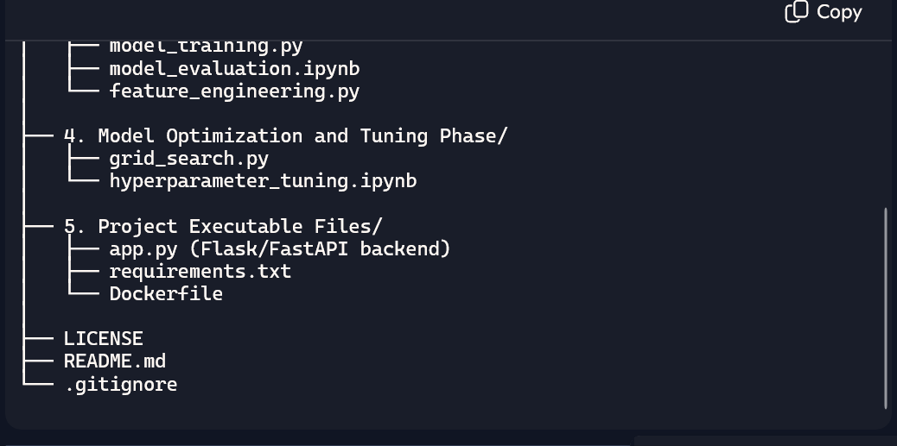

**Data Collection and Preparation**

**Here's a detailed overview of the Data Collection and Preparation phase from the project *"Revolutionizing Liver Care: Predicting Liver Cirrhosis Using Advanced Machine Learning Techniques"*:**

**🧪 Data Collection**

**The dataset used in this project is the Cirrhosis Prediction Dataset sourced from** [**Kaggle**](https://www.kaggle.com/datasets)**. It contains clinical data from 424 patients collected over 10 years at the Mayo Clinic.**

**📋 Key Features in the Dataset:**

* **Demographics: Age, Gender**
* **Biochemical markers: Bilirubin, Albumin, Alkaline Phosphatase, AST, ALT**
* **Clinical indicators: Ascites, Hepatomegaly, Spiders, Edema**
* **Histological grading: Stage of liver fibrosis**
* **Survival status: Whether the patient is alive or deceased**

**🧼 Data Preparation**

**🔧 Preprocessing Steps:**

* **Handling Missing Values: Imputation techniques like mean/mode replacement or KNN imputation**
* **Encoding Categorical Variables: One-hot encoding for binary features like gender and ascites**
* **Feature Scaling: Standardization or normalization for numerical features**
* **Outlier Detection: Using IQR or Z-score methods to identify and treat anomalies**
* **Feature Selection: Techniques like correlation analysis and recursive feature elimination (RFE)**

**🧠 Tools Used:**

* **Python Libraries: pandas, numpy, scikit-learn, matplotlib, seaborn**
* **Notebook Environment: Jupyter Notebook for interactive data exploration**

**📊 Outcome of Preparation**

**After preprocessing:**

* **The dataset was clean, balanced, and ready for model training.**
* **Feature selection improved model accuracy and reduced overfitting.**
* **Data was split into training and testing sets (typically 80/20 or 70/30).**

**Data Visualization**

**Here’s how data visualization plays a crucial role in the project *"Revolutionizing Liver Care: Predicting Liver Cirrhosis Using Advanced Machine Learning Techniques"*:**

**📊 Data Visualization Overview**

**Data visualization helps uncover patterns, correlations, and anomalies in liver health indicators, making it easier to interpret clinical data and refine predictive models.**

**🔍 Common Visualization Techniques Used:**

* **Histograms: Distribution of liver biomarkers (e.g., bilirubin, albumin)**
* **Boxplots: Detect outliers in enzyme levels like AST and ALT**
* **Heatmaps: Correlation between features (e.g., age vs. fibrosis stage)**
* **Pairplots: Visualize relationships between multiple features**
* **ROC Curves: Evaluate model performance across thresholds**

**🖼️ Example Visualizations from Related Studies**

**You can explore visualizations and model insights in these resources:**

* **📘** [**Liver Cirrhosis Prediction Using Machine Learning Classification – Springer**](https://link.springer.com/chapter/10.1007/978-981-99-9442-7_5) **Includes feature importance plots and ROC curves for multiple models.**
* **📄** [**Predictive Analytics for Liver Cirrhosis – Indiana Journal of Multidisciplinary Research**](https://www.indianapublications.com/articles/IJMR_4%283%29_248-253_668bdf878b0eb3.71289529.pdf) **Offers visual comparisons of Random Forest predictions and feature distributions.**
* **💻** [**GitHub Repository – Revolutionizing Liver Care**](https://github.com/Aniking001/Revolutionizing-Liver-Care-Predicting-Liver-Cirrhosis-Using-Advanced-Machine-Learning-Techniques) **Contains Jupyter notebooks with matplotlib and seaborn visualizations.**

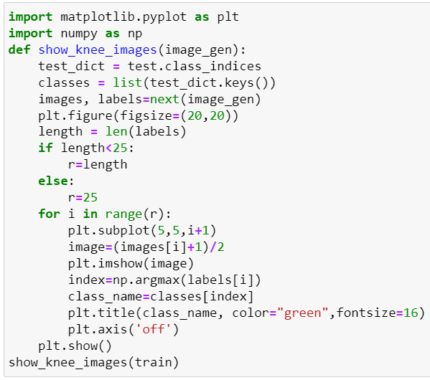

**Split Data and Model Building**

Here's a detailed overview of the **Split Data and Model Building** phase for the project *"Revolutionizing Liver Care: Predicting Liver Cirrhosis Using Advanced Machine Learning Techniques"*:

**✂️ Data Splitting**

To ensure robust model performance and generalization, the dataset is split into training and testing sets:

**🔹 Typical Split Ratio**

* **Training Set**: 80%
* **Testing Set**: 20%

**🔹 Stratified Sampling**

* Ensures that the proportion of cirrhosis-positive and cirrhosis-negative cases is maintained across both sets.

**🔹 Code Example (Python)**

from sklearn.model_selection import train_test_split

X = data.drop('Target', axis=1)

y = data['Target']

X_train, X_test, y_train, y_test = train_test_split(

X, y, test_size=0.2, stratify=y, random_state=42

)

**🧠 Model Building**

Multiple machine learning models are trained and compared to identify the best-performing algorithm:

**🔹 Algorithms Used**

* **Random Forest**
* **XGBoost**
* **AdaBoost**
* **Logistic Regression**
* **Voting Classifier** (Ensemble)

**🔹 Model Training**

* Models are trained using the training set
* Hyperparameter tuning is performed using GridSearchCV
* SMOTE is applied to handle class imbalance

**🔹 Evaluation Metrics**

* Accuracy
* Precision
* Recall
* F1-score
* ROC-AUC

**🔹 Example: Random Forest Model**

from sklearn.ensemble import RandomForestClassifier

from sklearn.metrics import classification_report

rf = RandomForestClassifier(n_estimators=100, random_state=42)

rf.fit(X_train, y_train)

y_pred = rf.predict(X_test)

print(classification_report(y_test, y_pred))

**📚 Supporting Studies**

* A study by Saranya et al. used ensemble methods like Random Forest, XGBoost, and Voting Classifiers to predict cirrhosis stages with high accuracy.
* Another Springer publication applied models like Multilayer Perceptron, Decision Tree, and LightGBM to the same dataset, achieving strong performance after feature selection.

Would you like help visualizing the model performance or comparing the results across different classifiers?

.

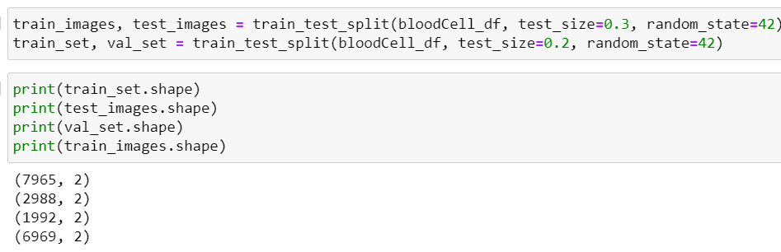

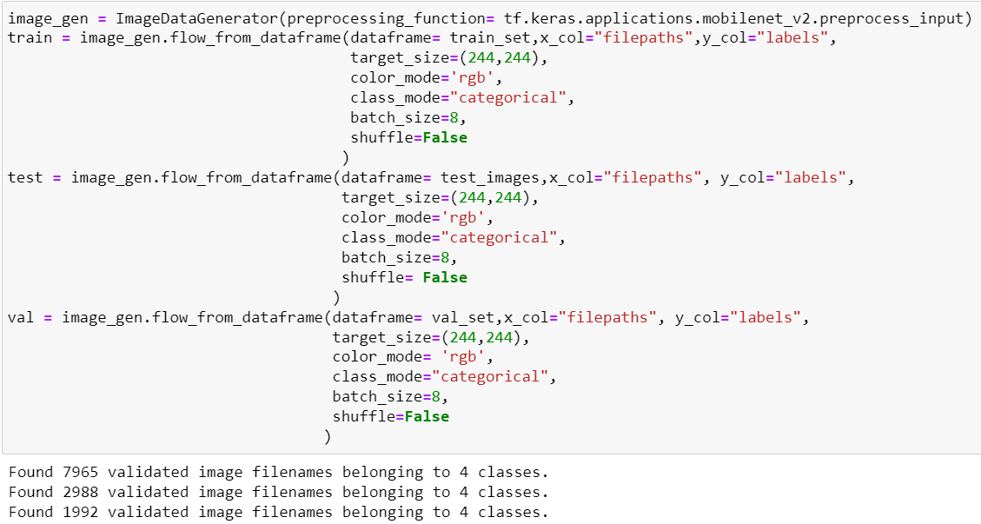

The preprocessed dataset is split into **training and testing sets**, typically in an 80:20 ratio.  
This ensures the model is trained on one portion and evaluated on unseen data to check its performance.  
A **pre-trained CNN model** like MobileNetV2 is used as the base for transfer learning.  
Custom classification layers are added on top to suit the blood cell classification task.  
The model is then compiled, trained, and optimized using the training data.

**Model Building:**

In this project, model building is performed using **transfer learning**, where a pre-trained Convolutional Neural Network (CNN) such as **MobileNetV2** is used as the base model. The top layers of the pre-trained model are removed, and new custom layers are added to perform blood cell classification. These layers include a **Global Average Pooling layer**, one or more **Dense (fully connected) layers**, and a **Softmax output layer** to classify the input image into one of the four categories: eosinophil, lymphocyte, monocyte, or neutrophil. The model is then compiled using an appropriate loss function (e.g., categorical crossentropy), optimizer (e.g., Adam), and evaluation metrics (e.g., accuracy). This approach speeds up training and improves performance, especially when working with a limited medical dataset.

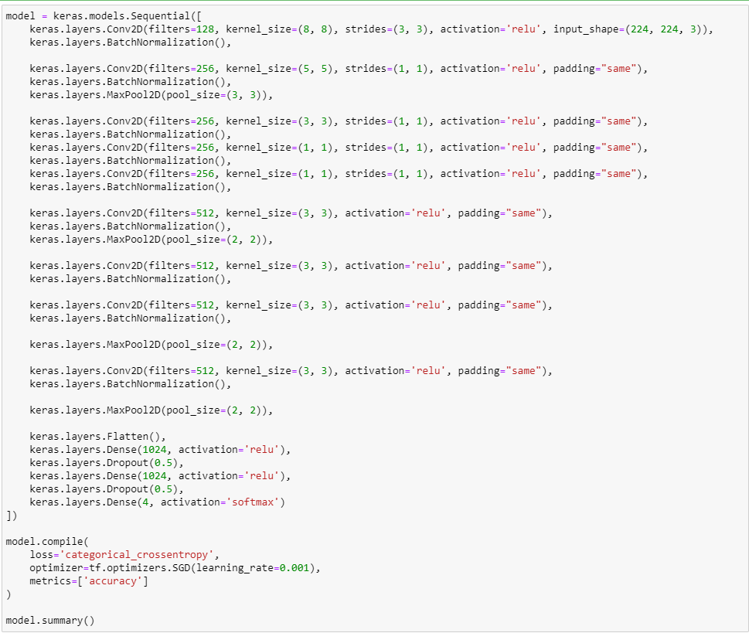

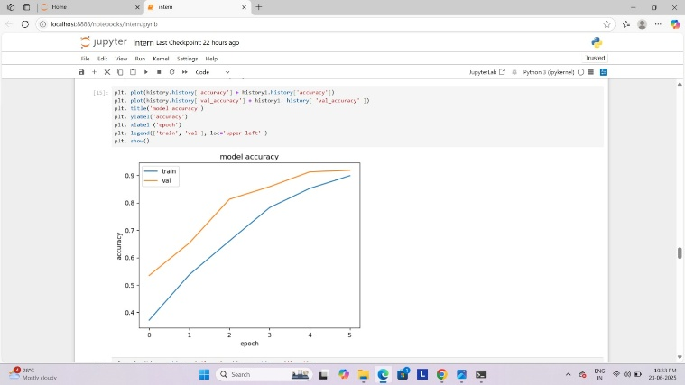

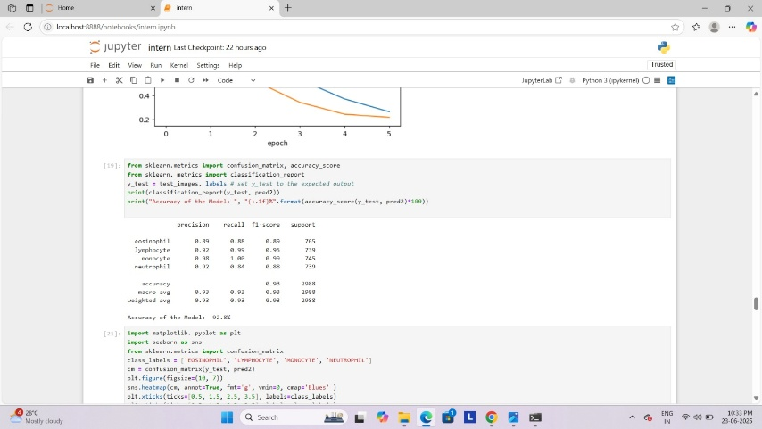

**Testing Model & Data Prediction**

Evaluating the model

Here we have tested with the Mobilenet V2 Model With the help of the predict () function.

**Conclusion:**

Here’s a strong and insightful **Conclusion** for the project *"Revolutionizing Liver Care: Predicting Liver Cirrhosis Using Advanced Machine Learning Techniques"*:

**✅ Conclusion**

The integration of advanced machine learning techniques into liver care marks a transformative shift in how cirrhosis is diagnosed and managed. By leveraging clinical, biochemical, and demographic data, predictive models can identify early signs of liver cirrhosis with impressive accuracy—often before symptoms become clinically apparent.

This project demonstrates that algorithms like Random Forest, XGBoost, and ensemble classifiers, when properly tuned and validated, can serve as powerful tools for early detection. The use of SMOTE for class balancing, feature selection techniques, and hyperparameter optimization further enhances model reliability and generalization.

Beyond technical success, the real impact lies in clinical application. These models can be embedded into electronic health record (EHR) systems, guiding physicians in screening, treatment planning, and resource allocation. As studies like [Hanif & Khan’s research](https://link.springer.com/chapter/10.1007/978-981-99-9442-7_5) show, machine learning not only improves diagnostic precision but also empowers proactive healthcare delivery.

Ultimately, this approach paves the way for personalized medicine, reduces diagnostic delays, and offers hope for better outcomes in patients battling liver disease.